**Experiment No:1**

**Problem Statement: : Basic Linux Command**

**NAME: Omkar Sunil Khanvilkar ROLLNO: 7**

**CLASS: IT-B BATCH: 2**

**DATE OF PERFORMANCE: 19/07/2024**

**___________________________________________________________________________**

# **General Purpose Commands**

## **1. date: To display current date & time of the system.**

**date**



2. cal :To display calendar of current month.

**cal**

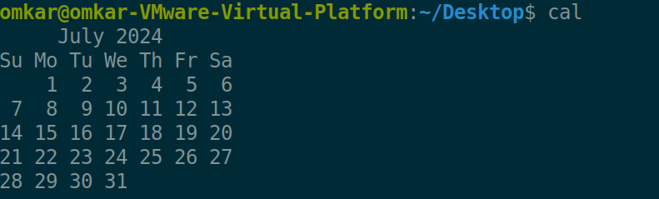

**cal -y**

Option y Display a calendar for the specified year. This option is implied when a year but no month are specified on the command line.

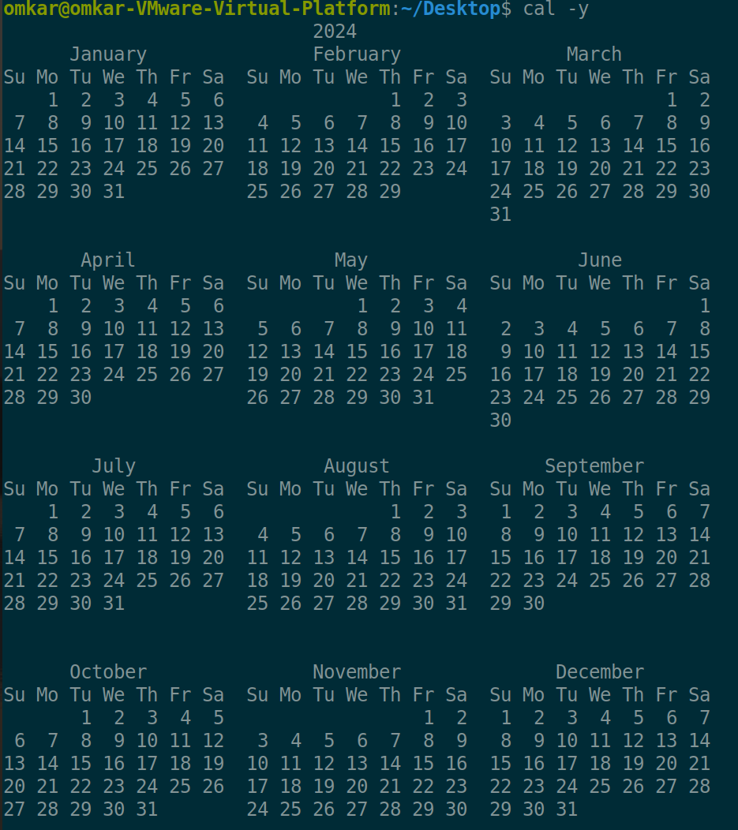

**cal -3**

Option 3 display the 3 months where 1st month is previous 2nd is present and 3rd is next

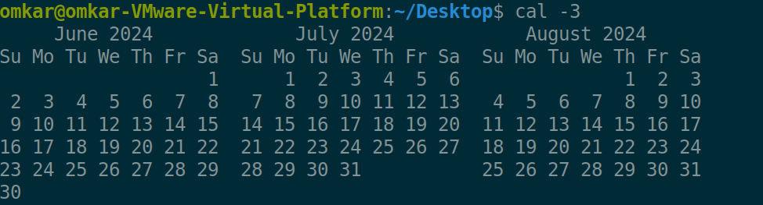

3. who:List who is currently logged on to the system.

**who**



**who -q**

Option q gives all login names and number of users logged on



4. Whoami:Report what user you are logged on as.

**whoami**



5. echo :Echo a string (or list of arguments) to the terminal

**echo**



**echo -n**

Option n is use to print the echo statement without any new line all statement get printed without any new line

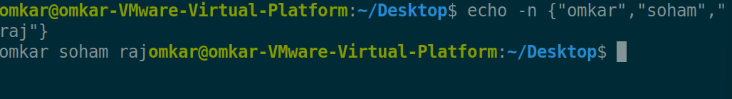

**echo -e**

Option e help us to use “escape sequence character”

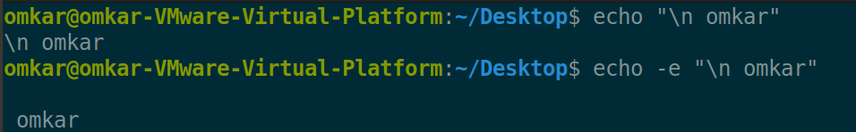

6. bc:To perform mathematical operations

**bc**

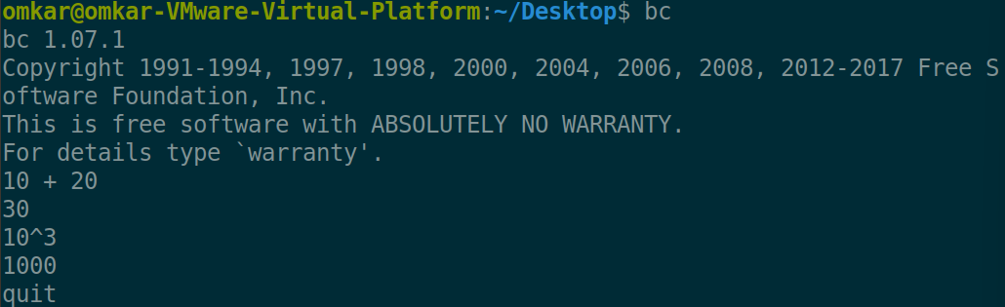

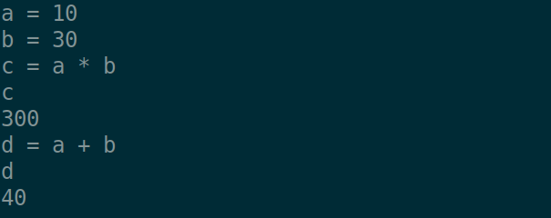

7. clear:To clear the screen

**clear**

8. alias : Used to tailor commands

Alias

Ex alias erase=rm Generate an employee report using AWK programming.

alias grep=”grep -i”

alias cp=“cp –i”

**alias newname=’ command’**

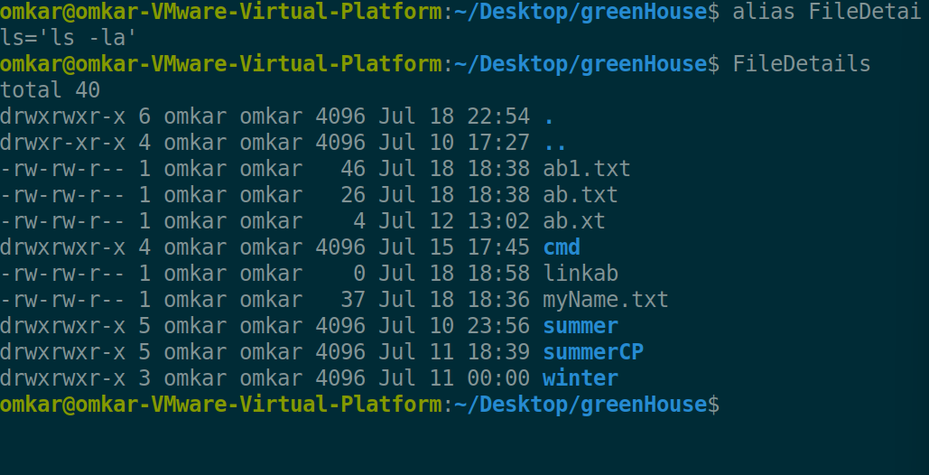

9. man <cmd name>: To get help for any command

**man**

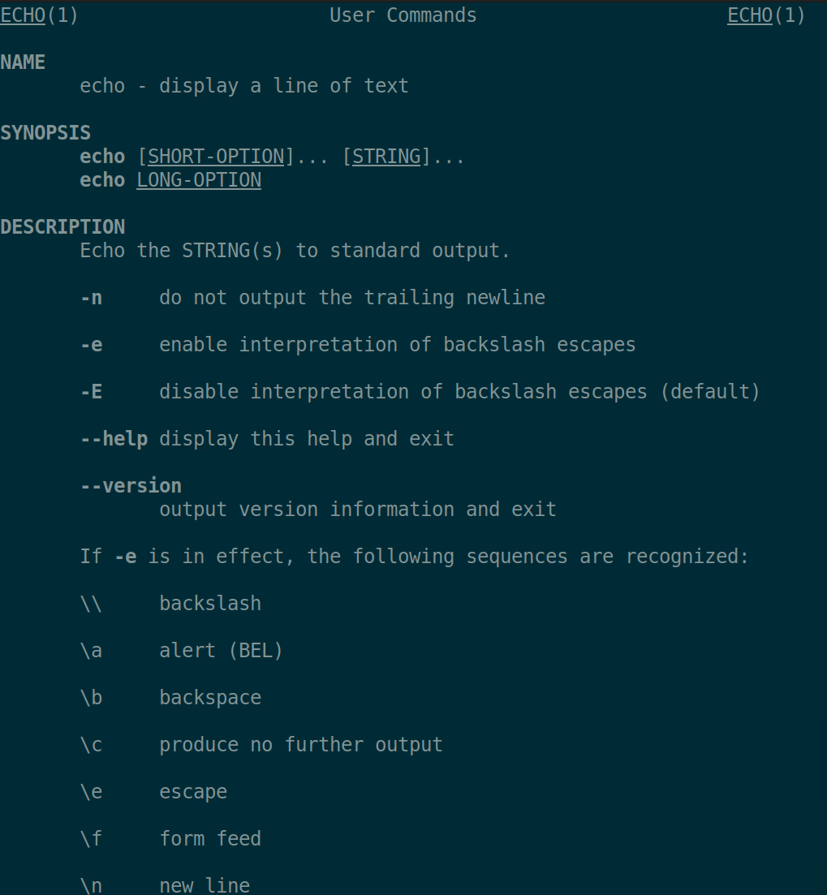

10. passwd: To change the password

**passwd**

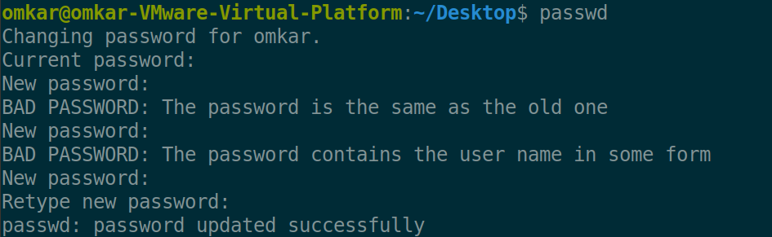

**Passwd - all**

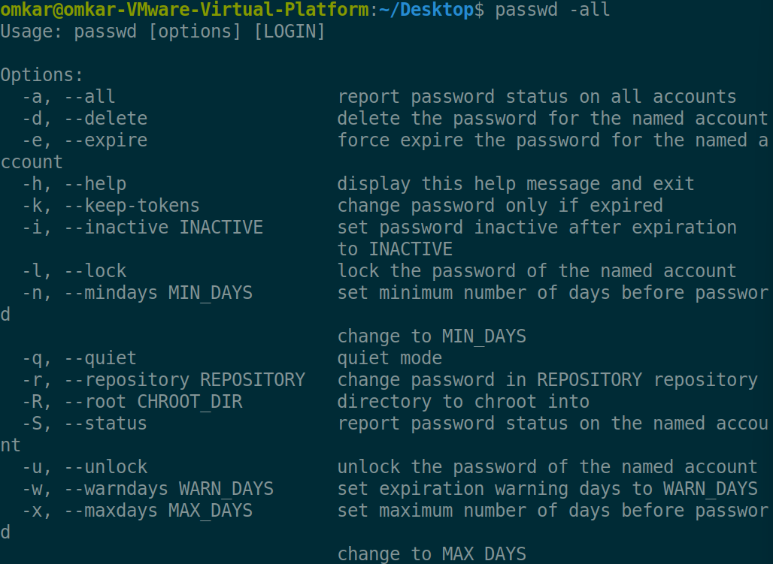

11. exit: To logout from the terminal

**exit**

12. cp <fromfile> <tofile>: Copy from the <fromfile> to the <tofile>

**cp fromFile toFile**

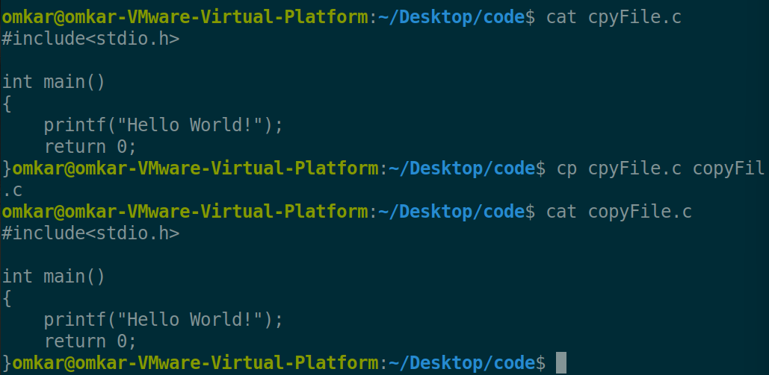

**cp -r fromFile toFile**

Option -r : Use to copy directory recursively

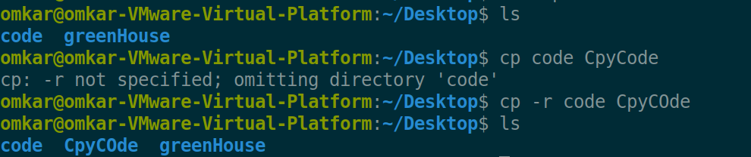

**cp -rv fromFile toFile**

Option -v : is for the verbose means it tell us about each and every step

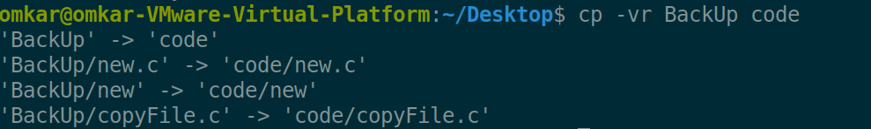

13. mv <fromfile> <tofile> : Move/rename the <fromfile> to the <tofile>

**mv fromFile toFile**

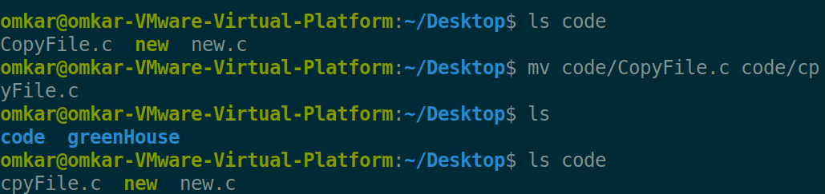

**mv -n fromFile toFile**

Option -n is use to avoid overwriting on the already existing the file

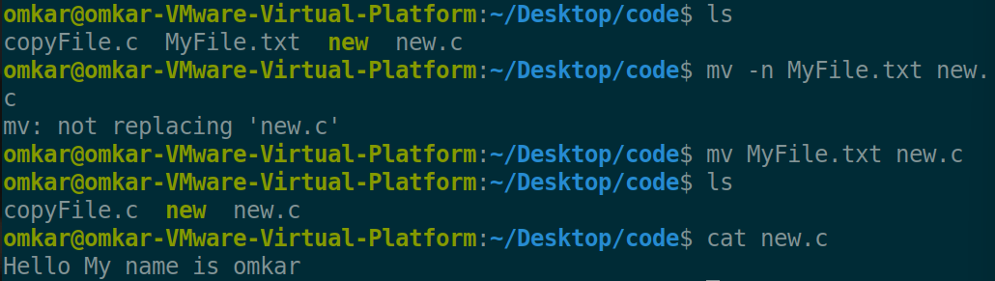

**mv -t fromDir toDir**

Option -t is use to move the particular directory inside another directory

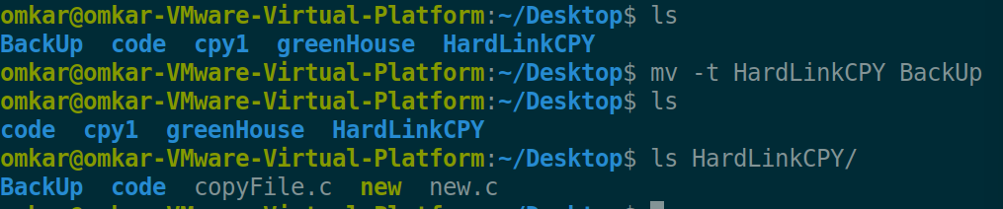

14. rm <file>:Remove the file named <file>

**rm fileName**

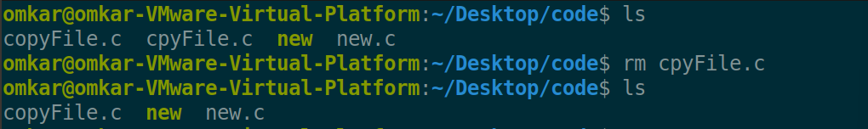

**rm -r fileName**

Option -r is the recursively remove the all files present inside the directory and also the remove the entire directory

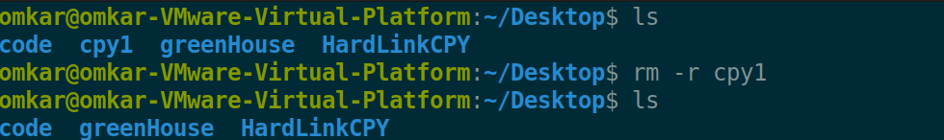

**rm -ri fileName**

Option -I give the prompt before the every removal

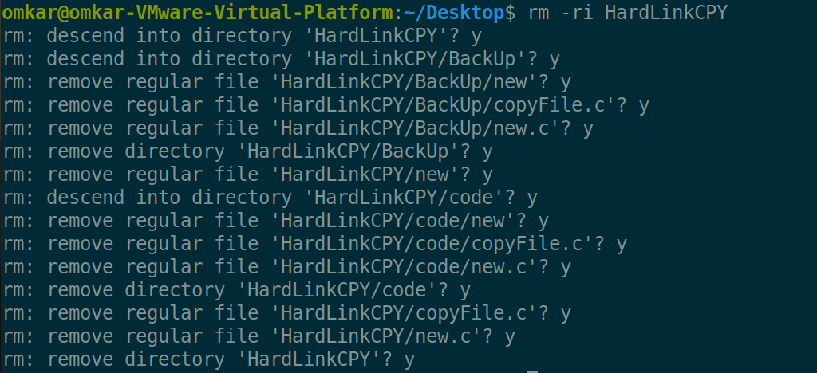

**rm -v fileName**

Option -v explain what is being done

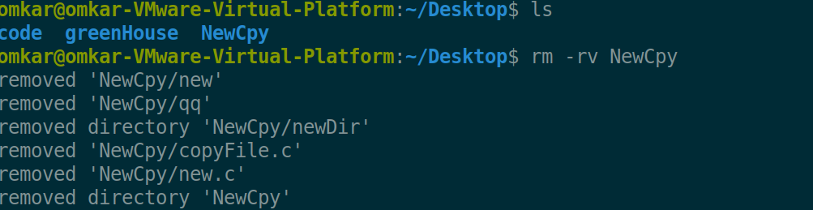

15. mkdir <newdir>:Make a new directory called <newdir>

**mkdir folderName**

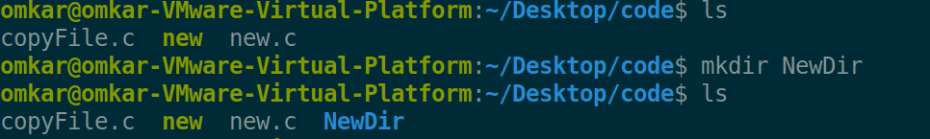

**mkdir -m=mode folderName**

Option -m is use to set the mode to the specific directory

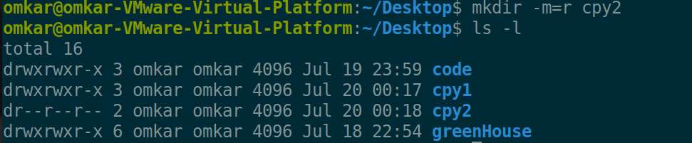

16. rmdir <dir>:Remove an (empty) directory

**rmdir folderName**

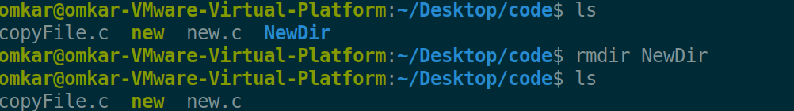

17. cd <dir> :Change the current working directory to dir

**cd folderName**

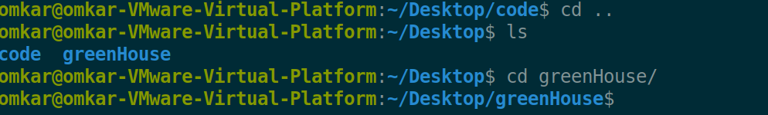

18. pwd : Print (display) the working directory

**pwd**



**pwd -P**

Option -P is use to show original file on the path when we are in it’s Link it actually ignores the link

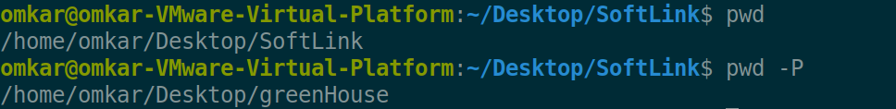

19. cat > <file> :To create new file n save it by pressing ^d

**cat >**

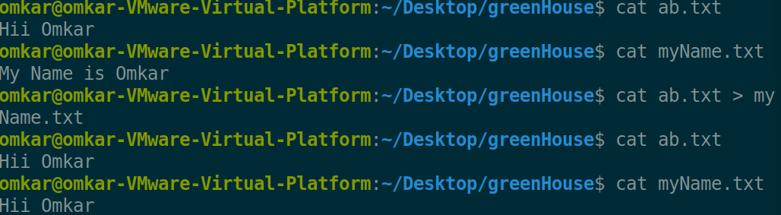

20. cat >> <file>: To append contents into file

**cat >>**

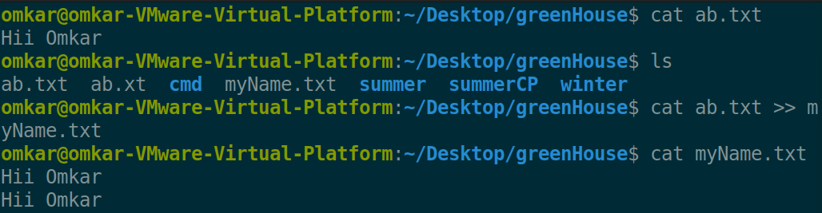

21. cat <file>:To see the contents of existing file

**cat**



**cat -A**

Option -A display all with $ at end of each line

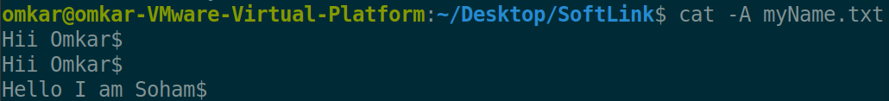

**cat -n**

Option -n display the line number at the start of every line

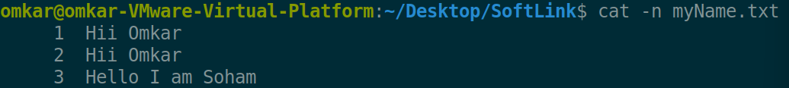

**cat -b**

Option -b is use to number only non blank files

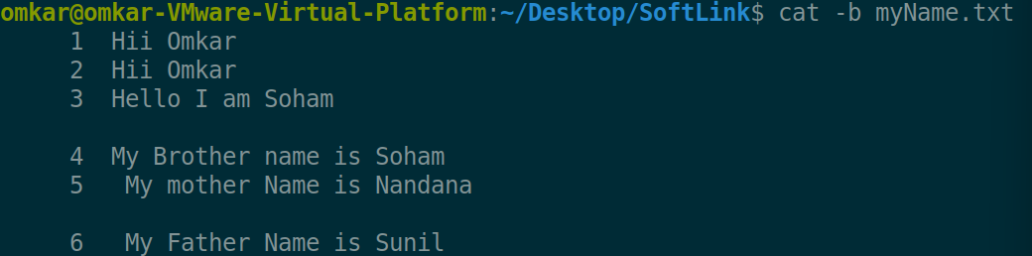

22. file <file>:To check the type of file

**file fileName**

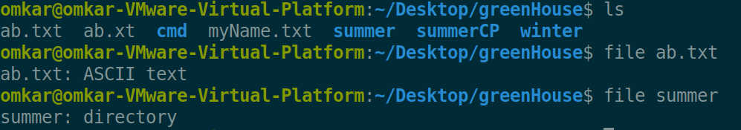

23. wc <file>:To count lines,words,charaters of file

**wc fileName**

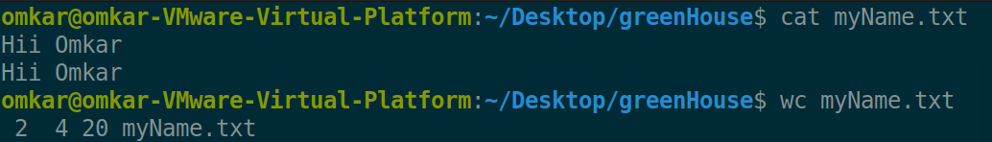

**wc -w/-l/-c fileName**

Option -w gives number of words

Option -l gives number of lines

Option -c gives number of characters

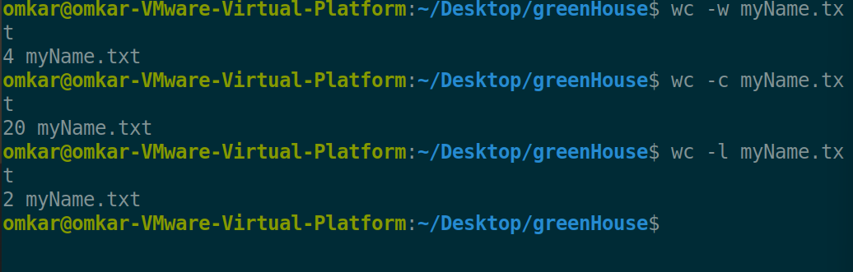

24. cmp <file1> <file2>:To compare two files

**cmp file1 file2**

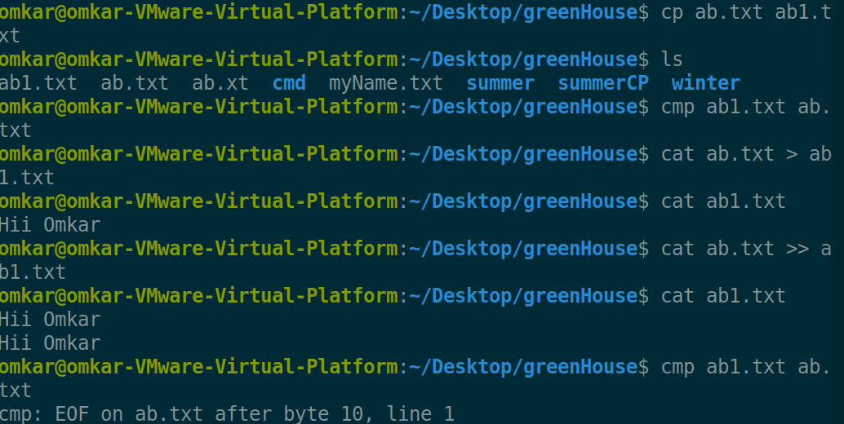

**cmp -l file1 file2**

Option -l explain the byte by byte comparison

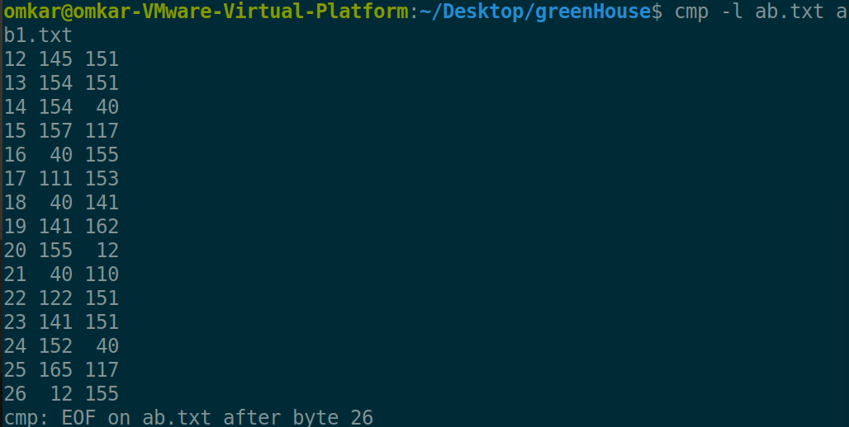

**cmp -i skipBytes1:skipBytes2 file1 file2**

Option – i is use to compare the 2 files by excluding or skipping some first bytes of file1 and file2

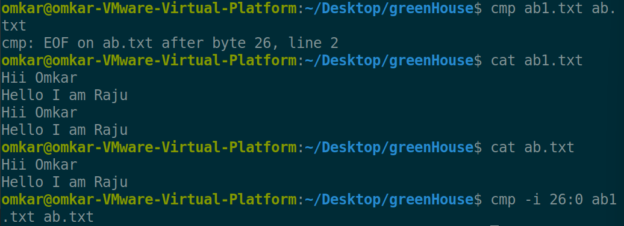

25. comm <file1> <file2>:To display common values between two files

**comm fileName1 fileName2**

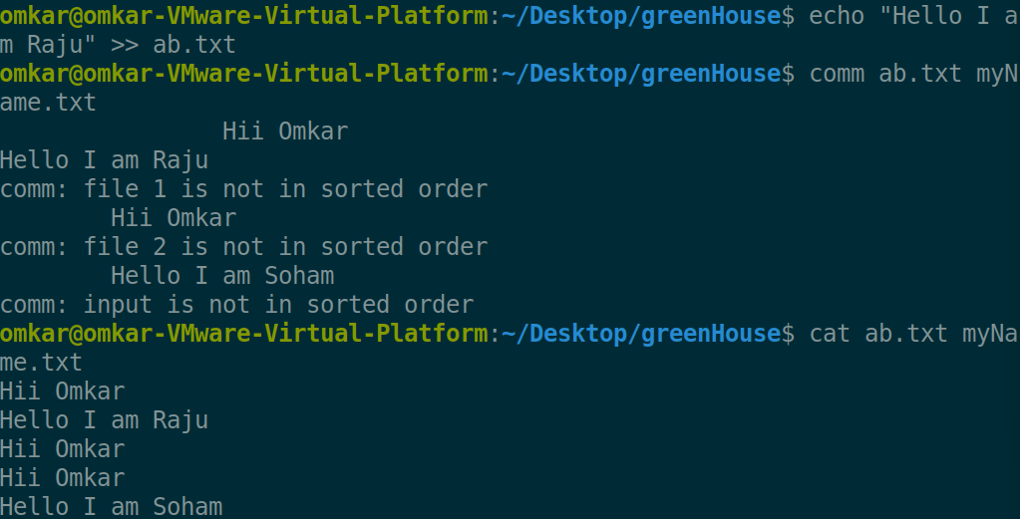

**comm –total fileName1 fileName2**

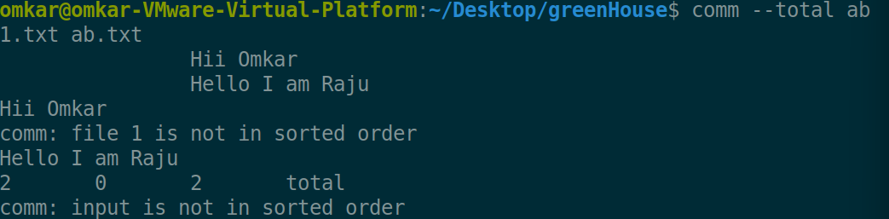

26. diff <file1> <file2>:To convert one file to another

**diff fileName1 fileName2**

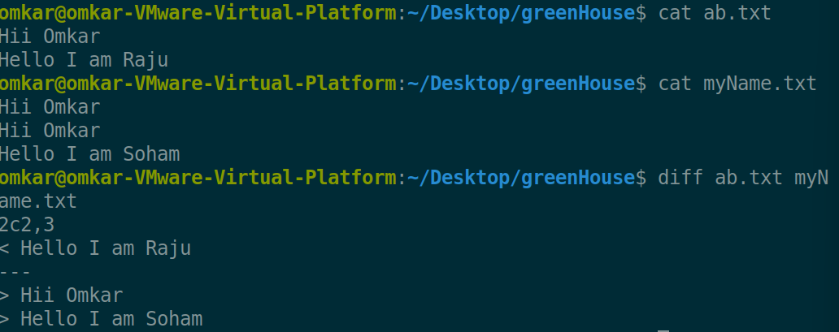

27. gzip <file>:To compress the file

**gzip fileName**

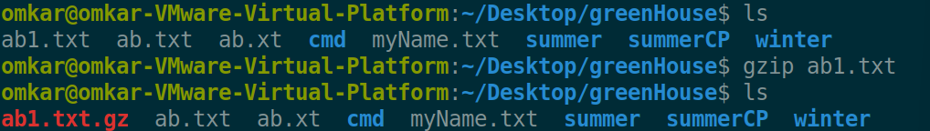

28. gunzip <file>:To unzip the contents of zipped file

**gunzip fileName**

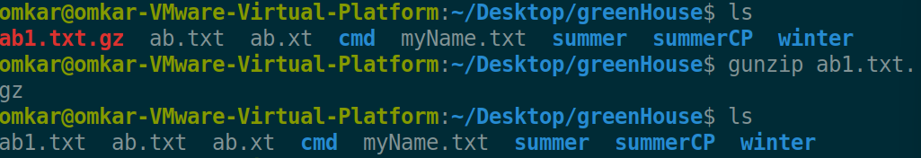

29. ls :List the files in the current working directory

**ls**



**ls -all**

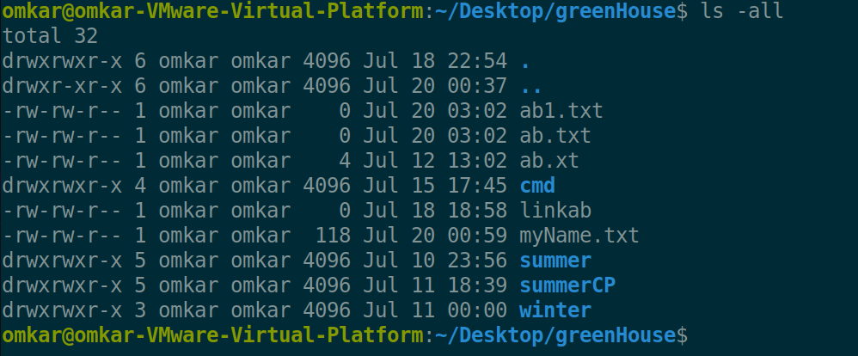

30. ln <fromfile><tofile>: Creates a symbolic link to a file

**ln fromFile toFile**

Linux have 2 types of links hard link & soft link

HardLink = If Original file is deleted still hardlink have the data of original file

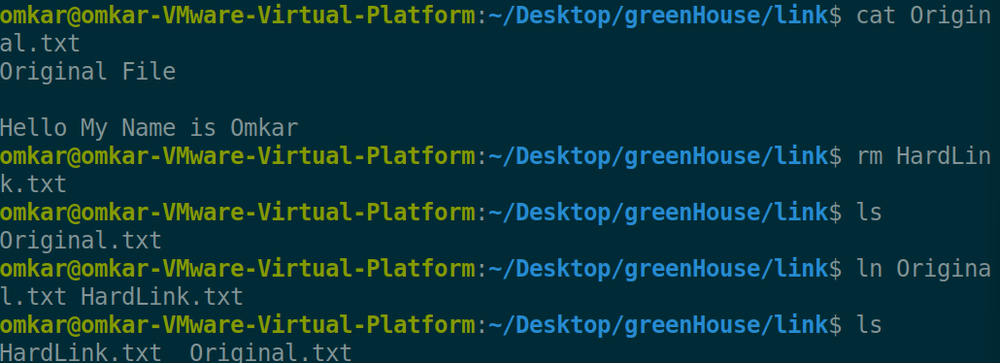

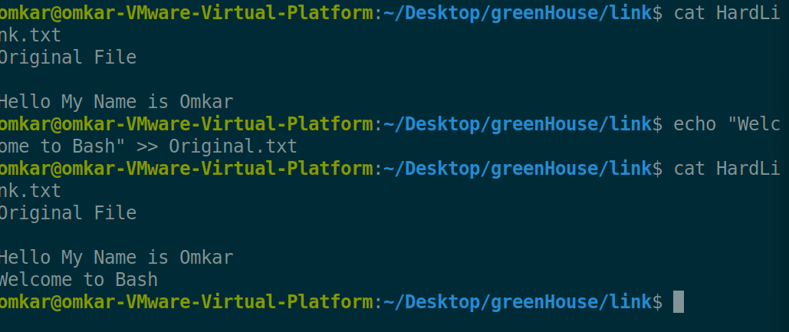

**Ln -s fromFile toFile**

SoftLink / Symbolic Link = this are such type of links which strictly linked with the file if the original file deleted then we cannot use this link like HardLinks

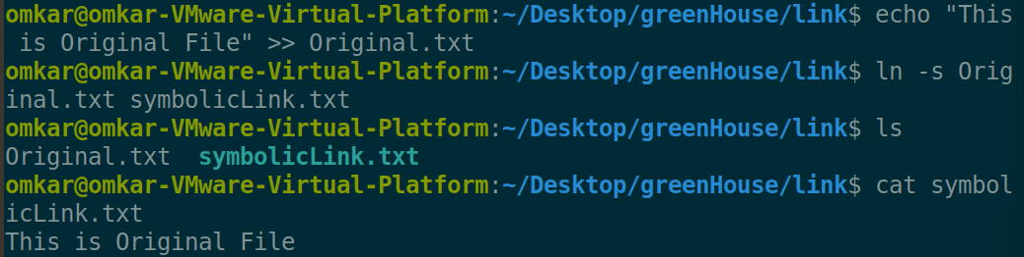

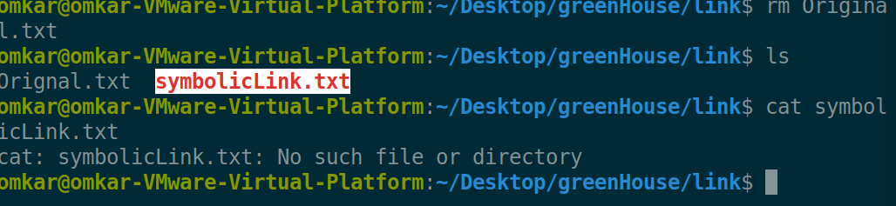

Error Redirection for all commands

**command 2> fileName**

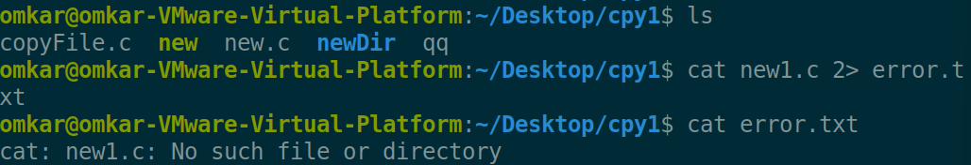

# **Commands Explore by me**

1. xdg-open use to open file

**xdg-open fileName**

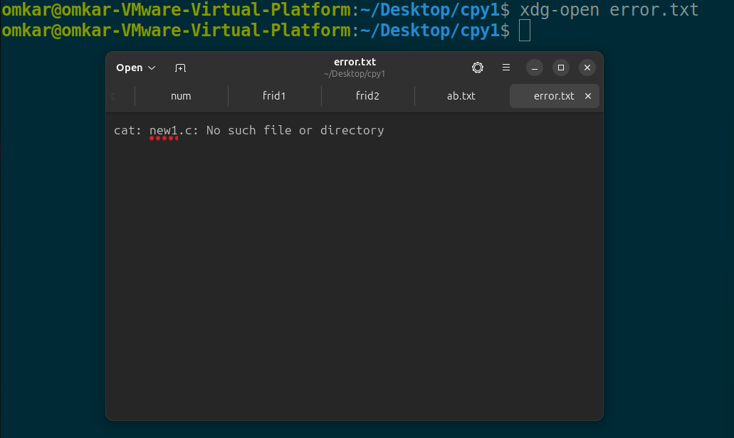

1. find command is use to search for files in a directory hierarchy

**find filename/R.E**

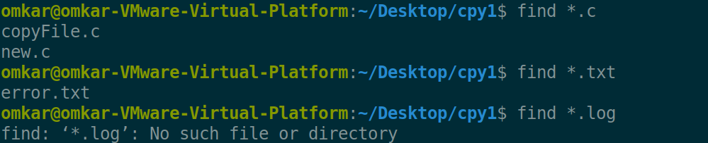

1. fortune - print a random, hopefully interesting, adage

**fortune**

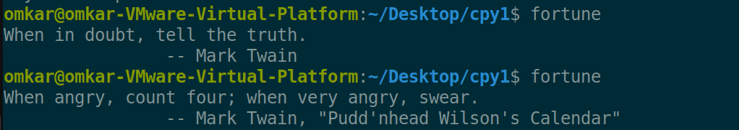

1. date command is use to get the current date & time

**date**



1. less - less command is use to read the long files because it provides the interactive window which contains the content of file but with some features

**less fileName**

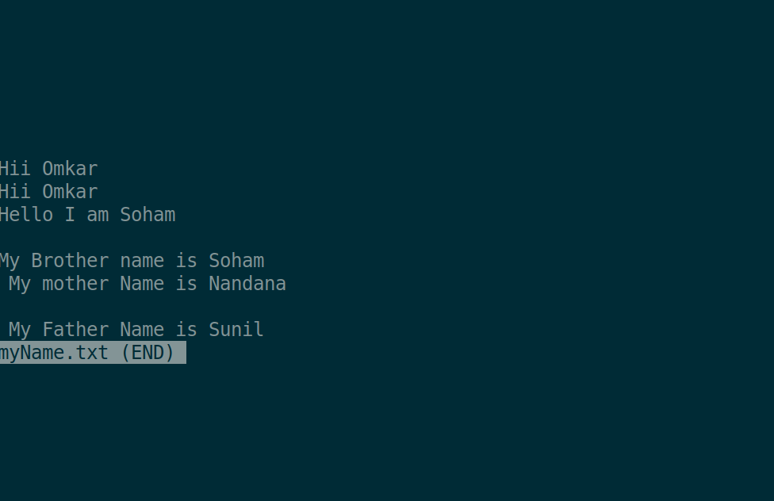

Conclusion: we have studied basic Linux command